**Bahria University, Lahore Campus**

Department of Computer Sciences

Lab Journal 10

**(Fall 2023)**

|  |  |  |
| --- | --- | --- |
| Course: | **Database Management System Lab** |  |
| Course Code: | CSL 220 | Max Marks: |
| Faculty’s Name: |  | Lab Engineer: |

Name: ____________________________________ Enroll No: _______________________

**Views**

**SQL Updating a View**

You can update a view by using the following syntax:

**SQL CREATE OR REPLACE VIEW Syntax**

CREATE OR REPLACE VIEW view_name AS

SELECT column_name(s)

Now we want to add the "Category" column to the "Current Product List" view. Wewill update the view with the following SQL:

CREATE OR REPLACE VIEW [Current Product List] AS

SELECT ProductID,ProductName,Category

FROM Products

WHERE Discontinued=No

**SQL Dropping a View**

You can delete a view with the DROP VIEW command

**SQL DROP VIEW Syntax**

DROP VIEW view_name

**Consider the following schema**

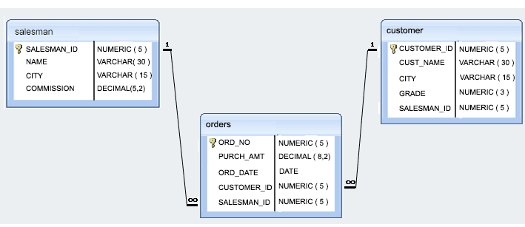

**Task 1**

* Write a query to create a view for those salesmen belongs to the city New York.
* Write a query to create a view for all salesmen with columns salesman_id, name, and city.
* Write a query to find the salesmen of the city New York who achieved the commission more than 13%.
* Write a query to create a view to get a count of how many customers we have at each level of a grade

**Task 2**

* Write a query to create a view that shows for each order the salesman and customer by name.
* Write a query to create a view that finds the salesman who has the customer with the highest order of a day.

Task 3

* Write a query to create a view that shows all matches of customers with salesman such that at least one customer in the city of customer served by a salesman in the city of the salesman.

**Task 4**

* Write a query to create a view that shows the number of orders in each day.
* Write a query to create a view that finds the salesmen who issued orders on either August 17th, 2012 or October 10th, 2012.

**Lab Grading Sheet**

|  |  |  |  |
| --- | --- | --- | --- |
| **Task** | **Max Marks** | **Obtained Marks** | **Comments(*if any*)** |
| 1. | 10 |  |  |
| 2. | 10 |  |  |
| 3. | 10 |  |  |
| 4. | 10 |  |  |
| **Total** | **40** |  | **Signature** |

**Note : Attempt all tasks and get them checked by your Lab. Instructor**

**Helping Material**

CREATE TABLE ABC

(

EMP_ID INT NOT NULL,

EMP_NAME VARCHAR (20) NOT NULL,

DEPT_ID INT NOT NULL,

DEPT_NAME CHAR (25) ,

DATE_OF_JOIN DATE

);

**How to create a view**

CREATE VIEW first­_view

AS

SELECT EMP_ID, EMP_NAME

FROM ABC;

**How to update a view**

UPDATE first_view

SET EMP_ID = 35

WHERE EMP_NAME ='Ramesh';

**How to delete a view**

DELETE FROM first_view

WHERE EMP_NAME = 'SAADIA';

**How to drop a view**

DROP VIEW first_view;